Byte of bellows on Maxi Fenix with MD5 and 110S.
The bellows on our Fenix numbers 445 each not changed afterwards the ship was produced. The bellows showed itself to be labeled with 1980! The ship was produced 1983, sows the bellows had been in use 23 years and shown themselves alltell therefore last 26 years, before the now was changed against a new.
Before the byte, I applied for information on the net and through asking miscellaneous people as had ship in many years. The shown itself that huge few had implemented the byte the actual. And all ojade itself over that varven takes shamelessly paid in order to do the. Between 7-10 the 000 exclusive bellows, that only the costs about 2200 paid tax sek.
Tillslut so found I two paragraphs descriptions on the net about how one goes about and the seemed on these two to last a quite simple operation. Some I spoke with mentioned that varven does the on some few hours.

Link to these: http://hem.passagen.se/s30/a1tekbalg.htm and http://www.lady-helmsman.org/motor.htm
Sows to the agency!
The day before the big willed happen, was dropped the oil from, the might stand openly over the night so the relative chewy oil got time on himself to run from. Take from the oil splinter so goes the faster, the seems to become vacuum in the drive which prevents that the oil runs out.
  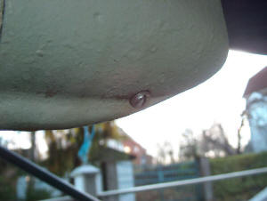
  Oljepluggen.
  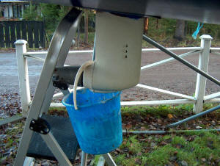
  Tune the run over the night.
  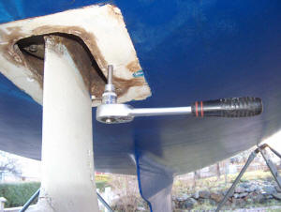
  The hole without täckplattan.
I began with clearing the rubber protection that sits for the hole in skrovet. This did I with a spackelspade, and the went entirely problem fritt. One can afterwards kränga of the from the drive wholly, sows is the from the road.
Since loosened I insex skruvarna underifrån that holds together the drive halves. The two that sits in the centers where little complicated to come to, I might drill two 10mm holes in flänsen in order to can to loosen these. This had I seen on those descriptions that existed on the net. Flänsen has no watertight spirit function (the is waters on both sides about the) sows the felt entirely harmlessly.
When now all skruva each loosened, is the subset of the drive loose and one can to let the to hang on flänsen.

  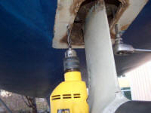
  Aim conscientiously so you drill on correct place!
  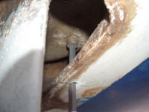
  Long insexnyckel for spärrskaft (8mm) facilitates.
  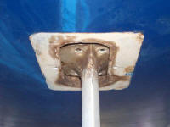
  Here, the lower half of the drive hangs in flänsen.
Now each the day's to makeacommitmentto in the ship and to loosen rear engine/the drive foothold and all skruvarna that holds the internal klämringen. First might I loosen the exhaust fume hose and to move away an off the batteries that where in the road.
When this was done so lifted we (for hand) up the engine and the drive in trail and intercepted a träkloss during. Now, one could easy tråckla out the old bellows and do purely anliggningsytorna.
  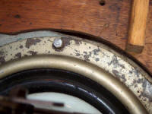
  Skruvarna (13mm) that holds internal klämringen.
  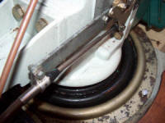
  All skruva out, almost.
  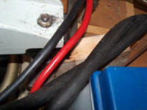
  Träkloss in order to the lifted rear foothold.
Now, one could easy tråckla out the old bellows and do purely anliggningsytorna. When this was done where the only to change o-ringen (as according to a Volvo Penta instruction from 1983 will be greased with not drying Permatex, this did not stand in the instruction as the the accompanied new bellows) that sits around the lower part of the drive's pass against the upper part and to ensure that the bellows lies centred and to skruva there some of skruvarna in order to hold all on-the-spot. Since releases one down the engine and the drive again and goes down on the land.
  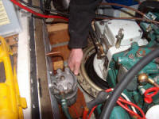
  Lifts the ring.
  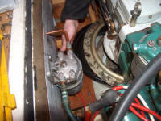
  Tråckla out the bellows
  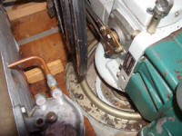
  The bellows bortlyft.
  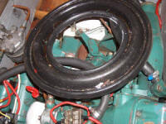
  The old bellows.
  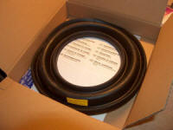
  The new bellows.
  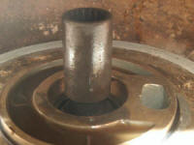
  The lower half of the drive's ovandel (o-ringen one changes catches a glimpse of on the internal ring).
  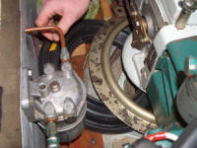
  The new bellows on road in.
  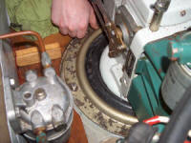
  The new bellows on-the-spot.
Now, the important is to check that the bellows's edge lies in avfasningen on the upper part of the drive.
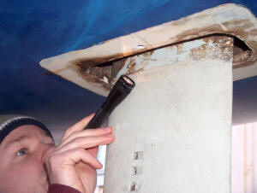
Check that the bellows lies in avfasningen around the whole the upper drive half.

Now, man product needs two, a that lifts the lower part of the drive on-the-spot and a that sets back least two of skruvarna and draws these with hand force. One can now unscrew there the rest skruvarna and to draw these sufficiently a lot of. Korsdra these according to the instruction for the bellows. Remembered that the drive is done of aluminum and that skruvarna will be drawn with aiming!

  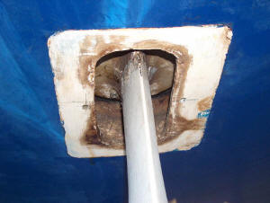
  The lower part of the drive on-the-spot again.
  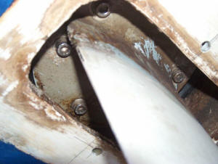
Now, the day's is to unscrew there the rest skruvarna to the upper klämringen, same thing here. Draw with aiming, the is not so kul that few gang pie in the ingjutna the capnuts. Finally, one skruva back the rear engine/the drive foothold, the exhaust fume hose and the battery that we moved on.
Do not forget to add oil in the drive, somewhere between 1,8 and 2,2 liters motor oil (the information goes apart about how a lot of oil that will be fulfilled, sows to check on the splinter!) (same type/quality on the oil that in MD5an).
  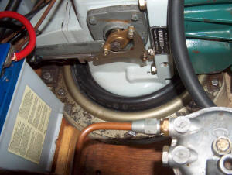
  All on-the-spot again, with new bellows!
  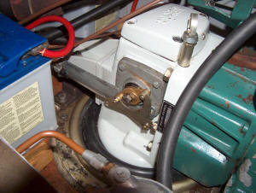
  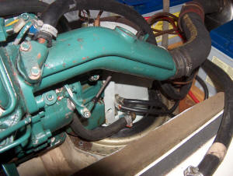
The last aspect is to glue back the rubber protection average drives and skrov. I used Sikaflex on recommendation of Drevia.

Now is the only to await the spring and to see about the became frequent. Jokes åsido, the structure does not permit almost that one does mis-. Dares you to change brakes on your car (which relatively is life dangerous) sows can you probably to change a bellows. You must however take on yourself that responsibility that the means to handle things that are to in order to hold the sea outside the ship. I take no responsibility through typing this. I want to only to demonstrate that the long from is impossible or horribly difficult. If you fail totally and you do not check about the is tätt the wide sea subsidence can of course the ship actual to fall with all what the means.
Fredrik
Fenix 445

Fotnot1: The bellows that was taken away had no damages or dry crevices. Quite fantastic in view of the age.
Fotnot2: This text and/or some picture sheep not entire or partial without the author's/the photographer's written approval be published on other place or in the other mediums than on Maxifenix.com.

